20123505 Introduction to Database System - Case Study

**Case 2 – Flight Reservations**

**Business needs**

* Record confirmed passenger reservation everyday
* Check the VIP status of different passenger to provide different special privileges, such as lounge, priority boarding and welcome drink
* Check the Food Allergies status of different passenger to prevent providing allergic meal to passenger and inform flight kitchens to prepare appropriate food
* List the Special Assistance status of different passenger to provide advanced action, such as prepare one more seats for assistance dog, pay attention to passenger who have medical device
* List the Special Requests status of different passenger on their flight to provide advanced action, such as provide child meal and vegetarian meal to passenger, prepare one more seats for wheel chair, provide advanced action to over-sized luggages and overweight luggages
* Provide the status summary including which flight is the most popular during a week

**Database Design**

Six Table and One Logical View

**Table FLIGHT**  
Basic information of each flight,

Flight_No is primary key and provide the number of each flight

Flight_FromCity and Flight_DepartureTime provide departure time and city

Flight_ToCity and Flight_ArrivalTime provide arrival time and city

Flight_TotalTime provide total time of each flight

Flight_TotalSeats provide total seats of each flight

**Table PASSENGER**  
Basic information of each passenger,

Passenger_No is primary key

Passenger_FirstName and Passenger_LastName provide the first name and last name of each passenger

Passenger_Gender provide the gender of each passenger

VIP_Code is a foreign key to link with table VIP to provide the level of VIP and special privileges

Passenger_PassportNumber provide the passport number of each passenger

Passenger_Nationality provide the nationality of each passenger

Passenger_Birthday provide the birthday of each passenger

Passenger_PhoneNumber provide the phone number of each passenger

Passenger_Email provide the email of each passenger

Passenger_AssistanceDog include a value either YES or No to determines the special need of assistance dog

FoodAllergies_Code is a foreign key to link with table FOODALLERGIES and provide information of food allergies on each passenger

Passenger_MedicalDevice include a value either YES or No to provide the special need to passenger who have medical device

**Table CLASS**  
Basic information of each cabin,

Class_Code is primary key and provide the alphabet represent different cabin

Class_Cabin provide different cabin

**Table VIP**  
Basic information of each VIP level,

VIP_Code is primary key and represent different VIP level

VIP_Lounge include a value either YES or No to determines the permission of entry the lounge on the airport

VIP_PriorityBoarding include a value either YES or No to determines the order of priority boarding between VIP and non-VIP

VIP_WelcomeDrink include a value either YES or No to provide the welcome drink to the VIP of ‘Gold’ level

**Table FOODALLERGIES**  
Basic information of different food allergies,

FoodAllergies_Code is primary key and provide the special code to represent different allergic food

FoodAllergies_Food include different allergic food

**Table INVOICE**  
Basic information of different invoice of different passenger,

Invoice_No is primary key and represent different number of invoice

Invoice_Date is the date of the flight

Flight_No is a foreign key and link to the primary key “Flight_No” of table FLIGHT and state the flight number which passenger will take

Passenger_No is a foreign key and link to the primary key “Passenger_No” of table PASSENGER in order to state the information of each passenger

Class_Code is a foreign key and link to the primary key “Class_Code” of table CLASS in order to state the class

Invoice_SeatRow provide the row of seat of each passenger on the flight

Invoice_SeatNo provide the no of seat of each passenger on the flight

Invoice_ChildMeal include a value either YES or No to determines the child meal of each passenger

Invoice_VegetarianMeal include a value either YES or No to determines the vegetarian meal of each passenger

Invoice_WheelChairs include a value either YES or No to determines the special need of wheel chairs

Invoice_OverSizedLuggages include a value either YES or No to show the over sized luggages on each passenger

Invoice_OverWeightLuggages include a value either YES or No to determines the overweight luggages on each passenger

**ER Diagram**

|  |
| --- |
| FK2  FK3  FK2  PK Flight_No  have  Belong  have  have  Belong  PK Class_Code  **FLIGHT**  Passenger_FirstName  Passenger_LastName  Passenger_Gender  VIP_Code  Passenger_PassportNumber  Passenger_Nationality  Passenger_Birthday  Passenger_PhoneNumber  Passenger_Email  Passenger_AssistanceDog  FoodAllergies_Code  Passenger_MedicalDevice  VIP_Lounge VIP_PriorityBoarding  VIP_WelcomeDrink  **VIP**  PK VIP_Code  PK FoodAllergies_Code  **FOODALLERGIES**  FoodAllergies_Food  FK1  PK Passenger_No  FK1  Class_Cabin  **CLASS**  PK Invoice_No  **PASSENGER**  **INVOICE**  Invoice_Date  Flight_No  Passenger_No  Class_Code  Invoice_SeatRow  Invoice_SeatNo  Invoice_ChildMeal  Invoice_VegetarianMeal  Invoice_WheelChairs  Invoice_OverSizedLuggages  Invoice_OverWeightLuggages  Flight_FromCity  Flight_ToCity  Flight_DepartureTime  Flight_ArrivalTime  Flight_TotalTime  Flight_TotalSeats |

Initial setup: Table PASSENGER: Basic information of each passenger

Table FLIGHT: Basic information of each flight

Table CLASS: Basic information of each cabin

Table VIP: Basic information of each VIP level

Table FOODALLERGIES: Basic information of different food allergies

Data entry by end-user:

INVOICE: Flight number, Seat row and number and different special requests

**Logic View POPULARFLIGHT**

CREATE VIEW POPULARFLIGHT AS

SELECT Flight_No, COUNT(Flight_No) AS MOSTPOPULAR

FROM INVOICE

GROUP BY Flight_No

ORDER BY MOSTPOPULAR DESC;

Sample results:

The most popular flight is CFX75, second popular flight are CFX52 and CFX45

**Test Result**

1. **List each special requests during a week on different flight:**
2. **Child meal:**

select INVOICE.Flight_No, INVOICE.Invoice_Date, INVOICE.Passenger_No, INVOICE.Invoice_No, INVOICE.Invoice_SeatRow, INVOICE.Invoice_SeatNo,

PASSENGER.Passenger_FirstName, PASSENGER.Passenger_LastName, INVOICE.Invoice_ChildMeal

from INVOICE, PASSENGER

where Invoice_ChildMeal like "YES" and INVOICE.Passenger_No = PASSENGER.Passenger_No;

Sample Results:

1. **Vegetarian Meal:**

select INVOICE.Flight_No, INVOICE.Invoice_Date, INVOICE.Passenger_No, INVOICE.Invoice_No, INVOICE.Invoice_SeatRow, INVOICE.Invoice_SeatNo,

PASSENGER.Passenger_FirstName, PASSENGER.Passenger_LastName, INVOICE.Invoice_VegetarianMeal

from INVOICE, PASSENGER

where Invoice_VegetarianMeal like "YES" and INVOICE.Passenger_No = PASSENGER.Passenger_No;

Sample Results:

1. **Use of wheel chairs:**

select INVOICE.Flight_No, INVOICE.Invoice_Date, INVOICE.Passenger_No, INVOICE.Invoice_No, INVOICE.Invoice_SeatRow, INVOICE.Invoice_SeatNo,

PASSENGER.Passenger_FirstName, PASSENGER.Passenger_LastName, INVOICE.Invoice_WheelChairs

from INVOICE, PASSENGER

where Invoice_WheelChairs like "YES" and INVOICE.Passenger_No = PASSENGER.Passenger_No;

Sample Results:

1. **Over-sized Luggages:**

select INVOICE.Flight_No, INVOICE.Invoice_Date, INVOICE.Passenger_No, INVOICE.Invoice_No, INVOICE.Invoice_SeatRow, INVOICE.Invoice_SeatNo,

PASSENGER.Passenger_FirstName, PASSENGER.Passenger_LastName, INVOICE.Invoice_OverSizedLuggages

from INVOICE, PASSENGER

where Invoice_OverSizedLuggages like "YES" and INVOICE.Passenger_No = PASSENGER.Passenger_No;

Sample Results:

1. **Overweight Luggages:**

select INVOICE.Flight_No, INVOICE.Invoice_Date, INVOICE.Passenger_No, INVOICE.Invoice_No, INVOICE.Invoice_SeatRow, INVOICE.Invoice_SeatNo,

PASSENGER.Passenger_FirstName, PASSENGER.Passenger_LastName, INVOICE.Invoice_OverWeightLuggages

from INVOICE, PASSENGER

where Invoice_OverWeightLuggages like "YES" and INVOICE.Passenger_No = PASSENGER.Passenger_No;

Sample Results:

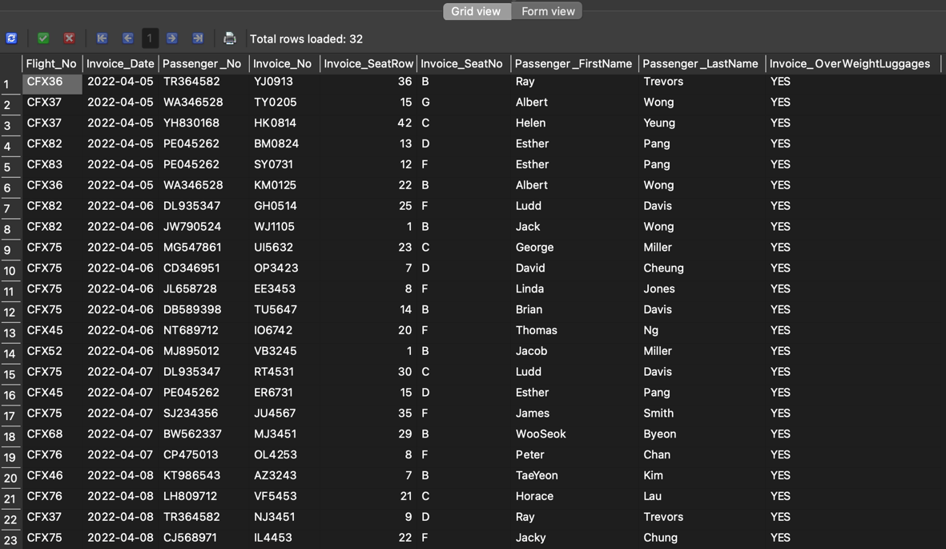

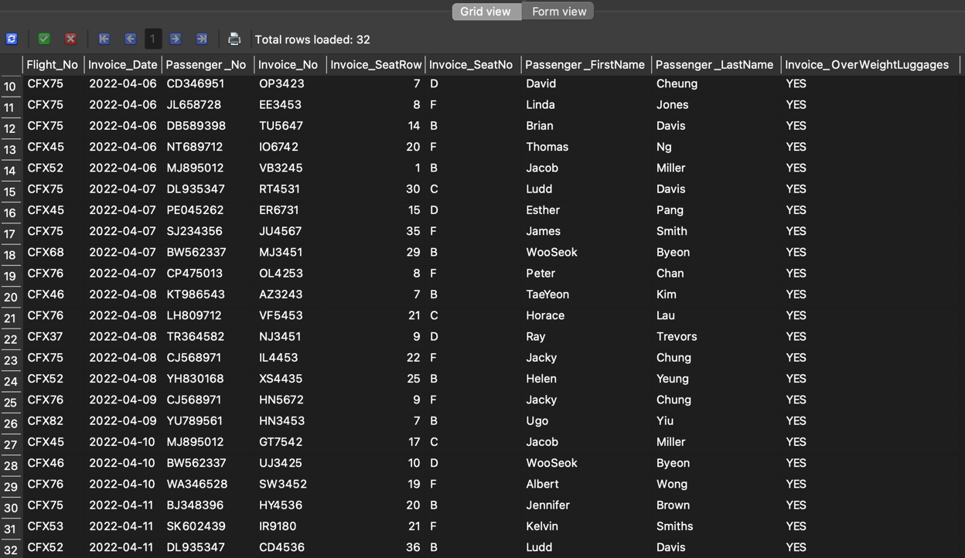

**“Overweight Luggages” is the most requested during a week on flight reservation**

**2. List the most popular row and seat that customer chosen**

**i. most popular row:**

select INVOICE.Invoice_SeatRow, INVOICE.Class_Code, count(INVOICE.Invoice_SeatRow) as MostPopularRow

from INVOICE

GROUP BY INVOICE.Invoice_SeatRow

ORDER BY MostPopularRow DESC;

Sample Results:

The most popular row is Row 1 and Row 9.

**ii. most popular seat:**

select INVOICE.Invoice_SeatNo, INVOICE.Class_Code, count(INVOICE.Invoice_SeatNo) as MostPopularNo

from INVOICE

GROUP BY INVOICE.Invoice_SeatNo

ORDER BY MostPopularNo DESC;

Sample Results:

The most popular seat number is seat B.

**3. List all passenger on the most popular flight(CFX75) in a week and its VIP special service**

select INVOICE.Flight_No, INVOICE.Passenger_No, PASSENGER.Passenger_FirstName, PASSENGER.Passenger_LastName, PASSENGER.VIP_Code,

VIP.VIP_Lounge, VIP.VIP_PriorityBoarding, VIP.VIP_WelcomeDrink

from INVOICE, PASSENGER, VIP

where INVOICE.Flight_No like "CFX75" and INVOICE.Passenger_No = PASSENGER.Passenger_No and PASSENGER.VIP_Code = VIP.VIP_Code;

Sample Results:

All of the passenger on the most popular flight both have “Priority Boarding”.

**4. List the total people of different food allergies**

select PASSENGER.FoodAllergies_Code, COUNT(PASSENGER.FoodAllergies_Code) as MostAllergiesFoodOnOurPassenger

from PASSENGER

GROUP BY PASSENGER.FoodAllergies_Code

ORDER BY MostAllergiesFoodOnOurPassenger DESC;

Sample Results:

“0” mean passenger don’t have food allergies and most of passengers don’t have food allergies but there are at least 3 passengers have milk allergy.

**5. List all passenger who need to pay attention and tack care to them, such as medical device and assistance dog**

**i. medical device**

select INVOICE.Invoice_Date, INVOICE.Flight_No, INVOICE.Passenger_No, INVOICE.Invoice_SeatRow ,INVOICE.Invoice_SeatNo,

PASSENGER.Passenger_FirstName, PASSENGER.Passenger_LastName, PASSENGER.Passenger_Gender, PASSENGER.Passenger_MedicalDevice

from PASSENGER, INVOICE

where INVOICE.Passenger_No = PASSENGER.Passenger_No and PASSENGER.Passenger_MedicalDevice like "%yes%" ;

Sample Results:

**ii. assistance dog**

select INVOICE.Invoice_Date, INVOICE.Flight_No, INVOICE.Passenger_No, INVOICE.Invoice_SeatRow ,INVOICE.Invoice_SeatNo,

PASSENGER.Passenger_FirstName, PASSENGER.Passenger_LastName, PASSENGER.Passenger_Gender, PASSENGER.Passenger_AssistanceDog

from PASSENGER, INVOICE

where INVOICE.Passenger_No = PASSENGER.Passenger_No and PASSENGER.Passenger_AssistanceDog like "%yes%" ;

Sample Results:

**6. Find the passenger who always take our company’s flight**

select INVOICE.Passenger_No, PASSENGER.Passenger_FirstName, PASSENGER.Passenger_LastName, PASSENGER.Passenger_Gender,

PASSENGER.Passenger_Birthday, Count (INVOICE.Passenger_No) as Most_TakeAFlight

from INVOICE,PASSENGER

where INVOICE.Passenger_No = PASSENGER.Passenger_No

GROUP BY INVOICE.Passenger_No

ORDER BY Most_TakeAFlight DESC;

Sample Results:

“Albert Wong” is always take our company’s flight during a week which company can ask him about flight’s service and why he choose our flights for improve our service and flight

**7. List all the passenger information who take flight on 2022/4/5 using LEFT OUTER JOIN**

select invoice.Invoice_No, invoice.Flight_No,

invoice.Invoice_Date, invoice.Passenger_No, Passenger.Passenger_FirstName, Passenger.Passenger_LastName,

Passenger.Passenger_Gender, Passenger.Passenger_PhoneNumber, Passenger.Passenger_Email

FROM invoice LEFT OUTER JOIN Passenger

on invoice.Passenger_No = Passenger.Passenger_No

where invoice.Invoice_Date = "2022-04-05" ;

Sample Results:

**Assumptions and Limitations**

* **All passengers have their flight during a period (2022/04/05 to 2022/04/11)**
* **If first time user booked a flight ticket on our flight reservations, it will become the basic VIP level – bronze level and record it on the database**
* **How Passenger use our Flight Reservations**
  + **Passenger will enter their information, such as name, gender, passport number, their VIP code and select their special needs (Assistance Dog, Food Allergies, Medical Device)**
  + **Then Passenger will choose their flight, Cabin, Seat Row and number, also select their special request (Child Meal, Vegetarian Meal, Use of wheel chairs, Over-sized Luggages, Overweight Luggages)**
  + **Above steps must not contain blank information and must not skip each step**
* **If a passenger didn’t choose their flight, database will only save his/her information and will not have his/her own invoice**
* **If a flight was cancelled due to different cause and deleted on table FLIGHT, flight number on table INVOICE will be error and be confusing as they are no corresponding foreign key on table FLIGHT**
* **If a passenger have food allergies that do not include in table “FOODALLERGIES”, it will not record it as the flight reservations only allow passenger choose the allergy food and they can’t type it on the flight reservations. It neglect the real situation of different people.**

**Conclusion**

**This design basically supports the stated requirements. In future, this design should be enhanced to cater for:**

* **Passenger not entering some unimportant information**
* **Summary on passenger who have not use our flight reservation system in a year**
* **Summary on passenger who always use our flight reservation system in a year**
* **Summary on passenger who always requests different special requests in a year**
* **Summary on gold VIP level passenger and which flight is the most taken among gold VIP level passenger**
* **Summary on how passenger choose the cabin under different situation, such as total flight time, destinations**
* **Not enforcing passenger become a bronze level VIP after they use our flight reservation system, system can add a Non-VIP on VIP code**
* **System also can add a visitors function. Under the visitors function, visitors can browse our system to check the time or destination of flight without entering personal information and becoming a VIP**
* **Allow passenger enter their allergy food which is not include in our list to protect the health of passenger and flight company**
* **Allow passenger enter their special requests in a comment box which is not include in the part of special requests or add more new special requests, such as require a window seats or aisle seats, require to seat with his/her family member, passenger with wheelchair or with children require to priority boarding, require an emergency exit row seat to have more space, require a seat which is far away from toilet or close to the kitchen**